**NAME:MASHEERA AFRIN**

**SUPERSET ID:6362071**

1. **ReactJS-handson**

**App.js**

import React from 'react';

function App() {

return (

<div>

<h1>Welcome to the first session of React</h1>

</div>

);

}

export default App;

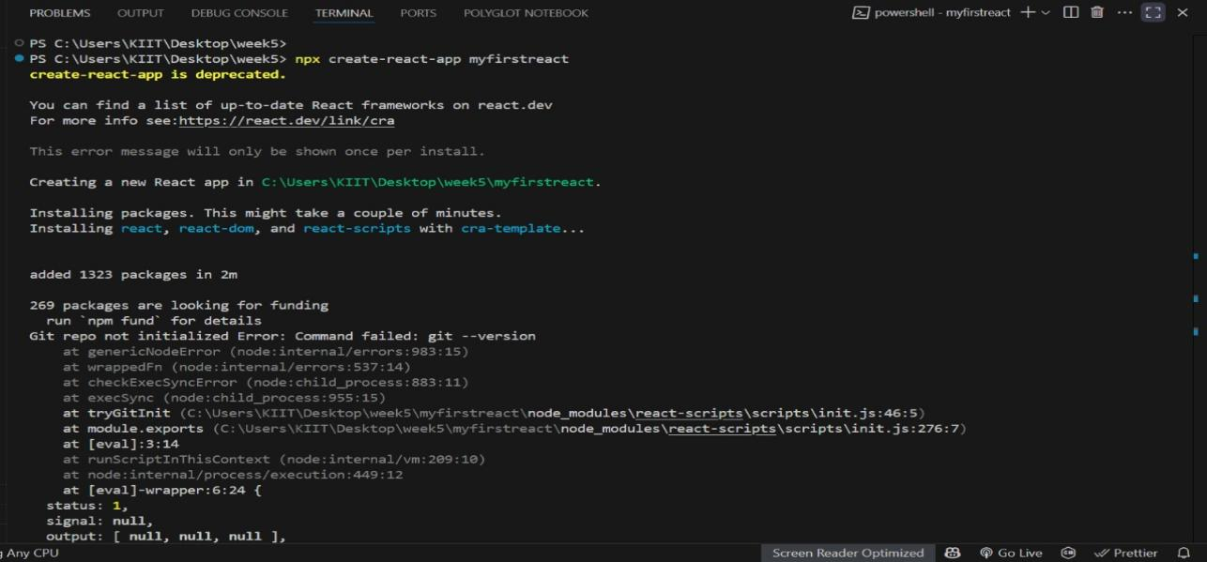

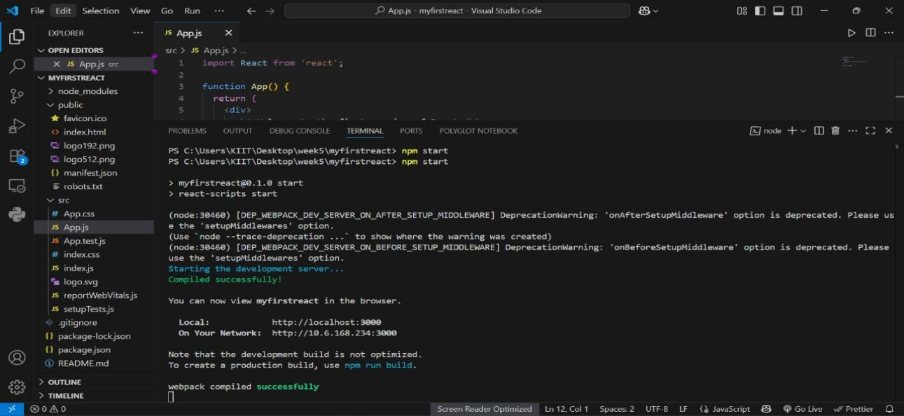

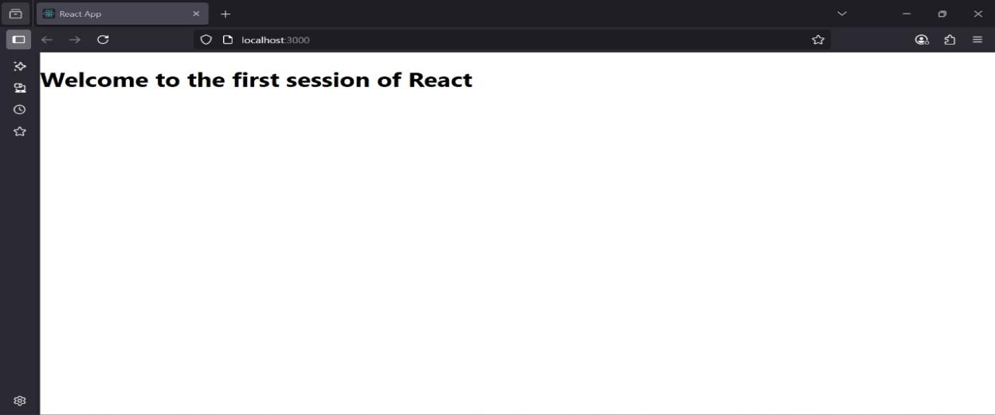

**2.ReactJS-Handson**

**About.js**

import React from 'react';

const About = () => {

return (

<div>

<h2>Welcome to the About page of the Student Management Portal</h2>

</div>

);

};

export default About;

**Contact.js**

import React from 'react';

const Contact = () => {

return (

<div>

<h2>Welcome to the Contact page of the Student Management Portal</h2>

</div>

);

};

export default Contact;

**Home.js**

import React from 'react';

const Home = () => {

return (

<div>

<h2>Welcome to the Home page of Student Management Portal</h2>

</div>

);

};

export default Home;

**App.js**

import React from 'react';

import Home from './Components/Home';

import About from './Components/About';

import Contact from './Components/Contact';

function App() {

return (

<div className="App">

<Home />

<About />

<Contact />

</div>

);

}

export default App;

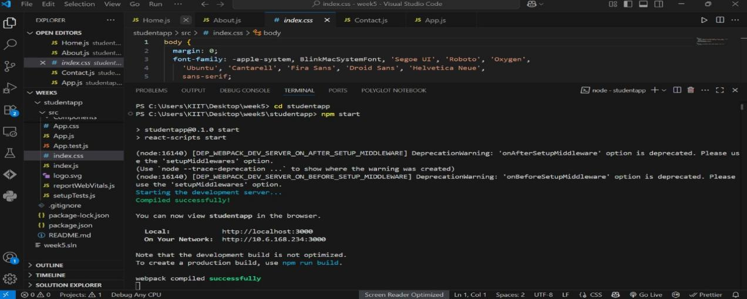

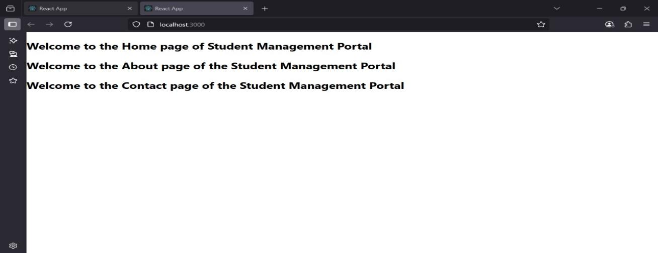

**3.ReactJs-Handson**

**CalculateScore.js**

import '../Stylesheets/mystyle.css';

const percentToDecimal = (decimal) => {

return decimal.toFixed(2) + '%';

};

const calcScore = (total, goal) => {

return percentToDecimal(total / goal);

};

const CalculateScore = ({ Name, School, total, goal }) => (

<div className="formatstyle">

<h1><font color="Brown">Student Details:</font></h1>

<div className="Name">

<b><span> Name: </span></b>

<span>{Name}</span>

</div>

<div className="School">

<b><span> School: </span></b>

<span>{School}</span>

</div>

<div className="Total">

<b><span>Total:</span></b>

<span>{total}</span>

<span> Marks</span>

</div>

<div className="Score">

<b>Score:</b>

<span>{calcScore(total, goal)}</span>

</div>

</div>

);

export default CalculateScore;

**Mystyle.css**

.Name {

font-weight: 300;

color: blue;

}

.School {

color: crimson;

}

.Total {

color: darkmagenta;

}

.formatstyle {

text-align: center;

font-size: large;

margin-top: 40px;

}

.Score {

color: forestgreen;

}

**App.js**

import React from 'react';

import CalculateScore from './Components/CalculateScore';

function App() {

return (

<div>

<CalculateScore

Name="Steeve"

School="DNV Public School"

total={284}

goal={300}

/>

</div>

);

}

export default App;

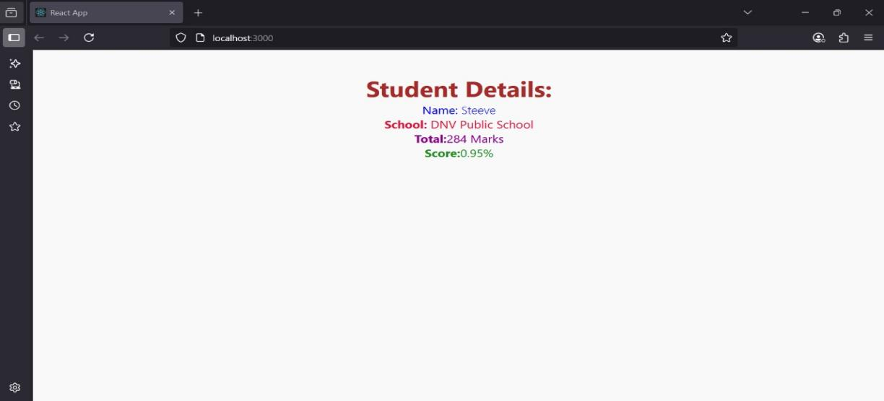

**4.ReactJS-Handson**

**App.js**

import React from 'react';

import Posts from './Posts';

function App() {

return (

<div className="App">

<Posts />

</div>

);

}

export default App;

**Post.js**

import React from 'react';

function Post(props) {

return (

<div>

<h2>{props.title}</h2>

<p>{props.body}</p>

</div>

);

}

export default Post;

**Posts.js**

import React from 'react';

import Post from './Post';

class Posts extends React.Component {

constructor(props) {

super(props);

this.state = {

posts: []

};

}

componentDidMount() {

this.loadPosts();

}

loadPosts() {

fetch("https://jsonplaceholder.typicode.com/posts")

.then(response => response.json())

.then(data => {

const postObjects = data.map(p => ({

id: p.id,

title: p.title,

body: p.body

}));

this.setState({ posts: postObjects });

});

}

render() {

return (

<div>

<h1>All Posts</h1>

{this.state.posts.map(p => (

<Post key={p.id} title={p.title} body={p.body} />

))}

</div>

);

}

}

export default Posts;

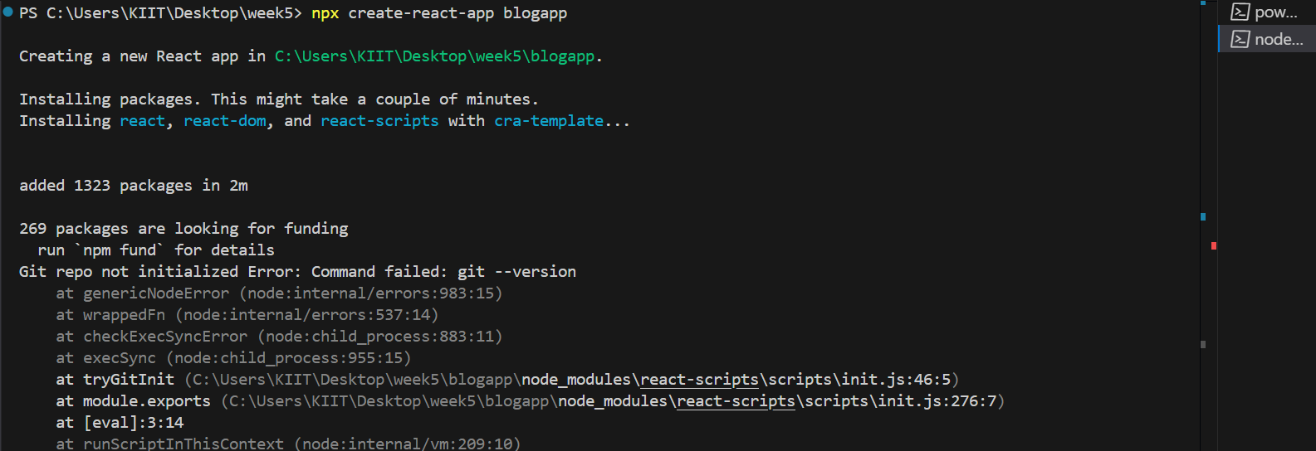

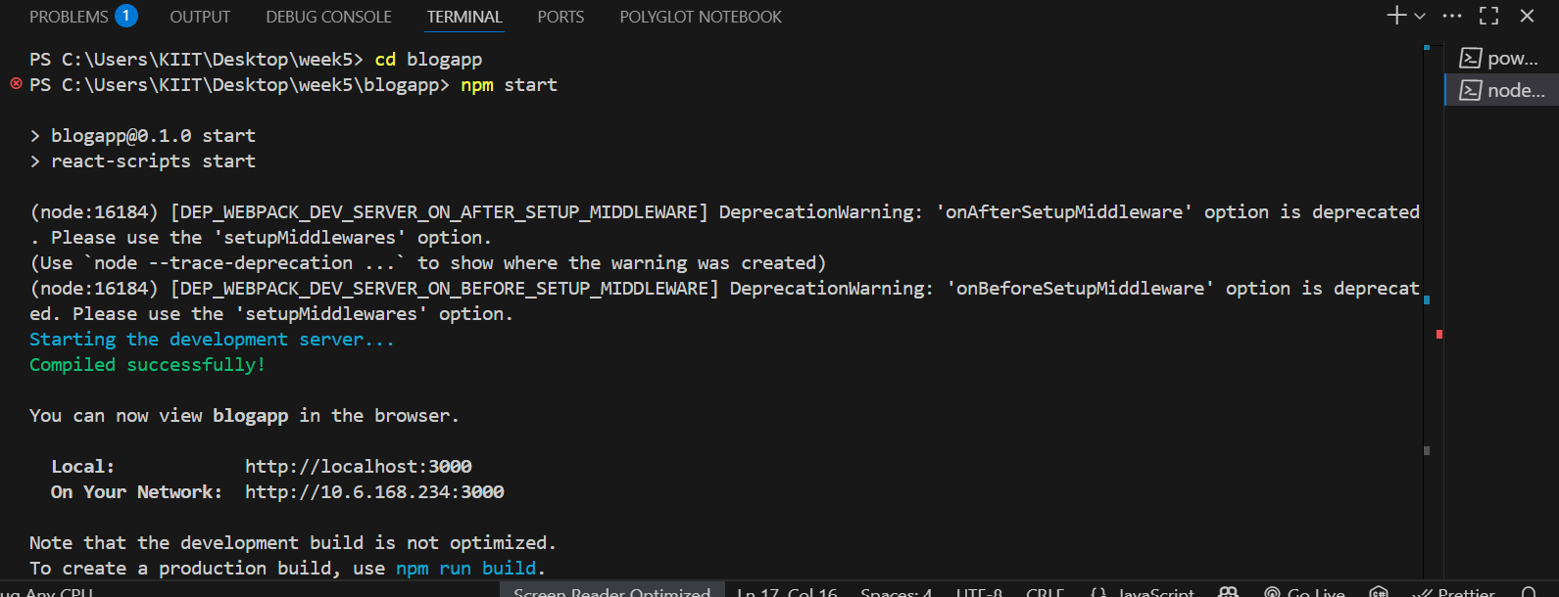

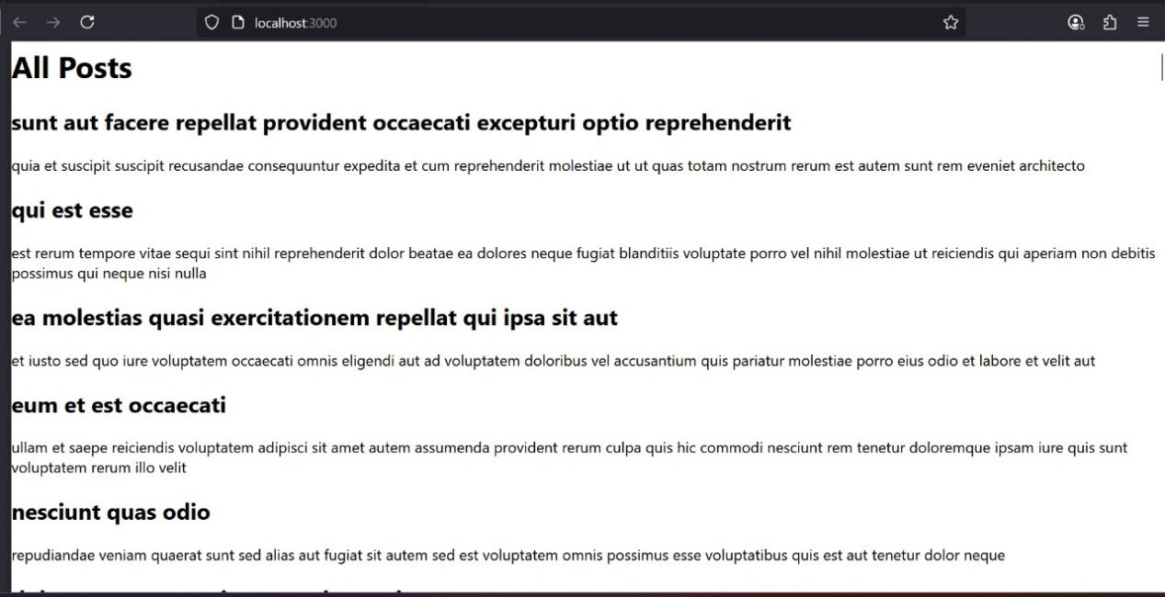

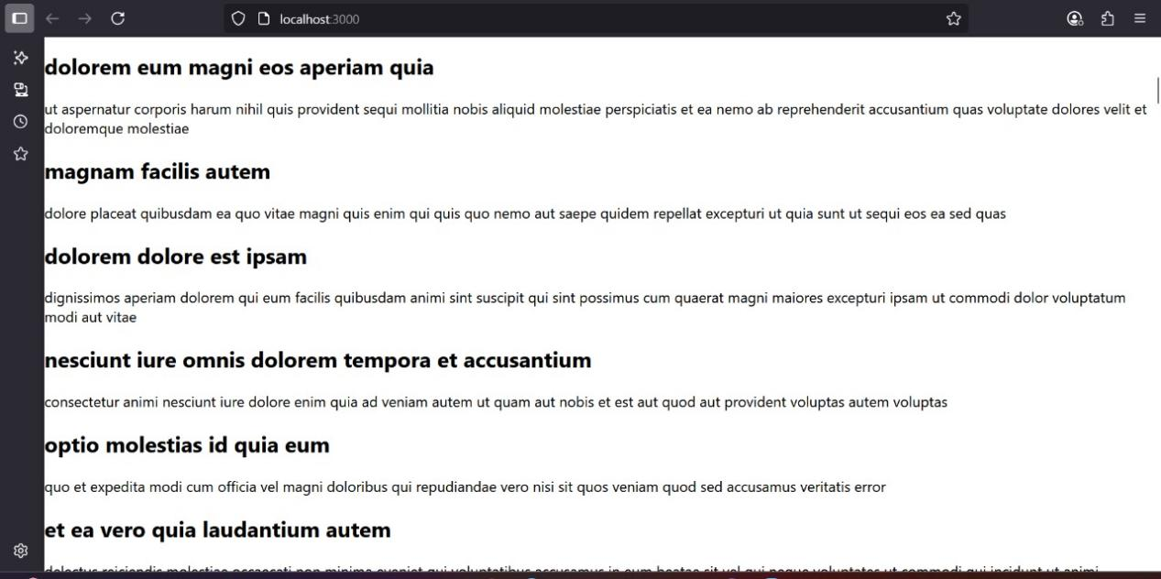

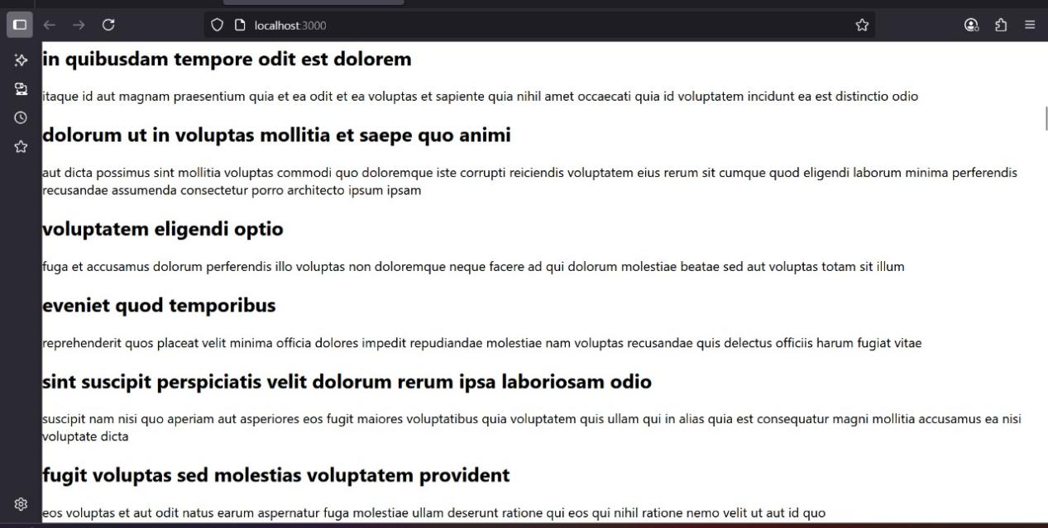



1. **ReactJS-HOL**

**CohortDetail.jsx**

import React from 'react';

import styles from './CohortDetails.module.css';

const CohortDetails = ({ cohort }) => {

const headingColor = cohort.status === 'Ongoing' ? 'green' : 'blue';

return (

<div className={styles.box}>

<h3 style={{ color: headingColor }}>{cohort.name}</h3>

<dl>

<dt>Started On</dt>

<dd>{cohort.startDate}</dd>

<dt>Current Status</dt>

<dd>{cohort.status}</dd>

<dt>Coach</dt>

<dd>{cohort.coach}</dd>

<dt>Trainer</dt>

<dd>{cohort.trainer}</dd>

</dl>

</div>

);

};

export default CohortDetails;

**CohortDashboard.jsx**

import React from 'react';

import CohortDetails from './CohortDetails';

const cohortList = [

{

name: 'INTADMDF10 - .NET FSD',

startDate: '22-Feb-2022',

status: 'Scheduled',

coach: 'Aathma',

trainer: 'Jojo Jose'

},

{

name: 'ADM21JF014 - Java FSD',

startDate: '10-Sep-2021',

status: 'Ongoing',

coach: 'Apoorv',

trainer: 'Elisa Smith'

},

{

name: 'CDBJF21025 - Java FSD',

startDate: '24-Dec-2021',

status: 'Ongoing',

coach: 'Aathma',

trainer: 'John Doe'

},

{

name: 'INTADMJF12 - Java FSD',

startDate: '22-Feb-2022',

status: 'Scheduled',

coach: 'Ibrahim',

trainer: 'To Be Assigned'

},

{

name: 'CDE22JF011 - Java FSD',

startDate: '24-Dec-2021',

status: 'Ongoing',

coach: 'Apoorv',

trainer: 'Emma Swan'

},

{

name: 'INTADMDF09 - Dataware Housing',

startDate: '22-Feb-2022',

status: 'Scheduled',

coach: 'Aathma',

trainer: 'Babjee Rao'

},

{

name: 'ADM22DF001 - .NET FSD',

startDate: '10-Sep-2021',

status: 'Ongoing',

coach: 'Ibrahim',

trainer: 'Marie Curie'

}

];

const CohortsDashboard = () => {

return (

<div>

<h2>Cohorts Details</h2>

{cohortList.map((cohort, index) => (

<CohortDetails key={index} cohort={cohort} />

))}

</div>

);

};

export default CohortDashboard;

**App.js**

.box {

width: 300px;

display: inline-block;

margin: 10px;

padding: 10px 20px;

border: 1px solid black;

border-radius: 10px;

}

dt {

font-weight: 500;

}

